Title:

The Economics of Gender Pay Gaps in Sports: How Revenue, Media Coverage, and Investment Shapes Earnings for Female Athletes.

Madhav Pransukhka
BA. (Hons) PPE-2025

One of the most striking examples of a broader bias in today’s economy is the gender pay gaps in sports. Men playing football, cricket and basketball, receive multi-million-dollar contracts and their performances are backed by powerful global brands. Women who compete at an equal level receive overwhelmingly less money. This isn’t just about who is a better player or who attracts more fans, it’s about how money, culture and media combine to create a system that pulls women back.
Proponents of the pay gap claim it is only a matter of economics. Men’s sports generate more money, so male players should earn more. However, this argument falls apart once we look at how that financial gap was created. Throughout history, men’s leagues have garnered more financial resources and promotions. As a result, it has created an environment where male athletes have more access to resources and more opportunities to build an audience. Women’s leagues get less support and cannot grow in the same way due to this. This unequal support did not arise naturally, it arose because men’s sports were professionalised, broadcast and funded decades earlier, giving them a path-based advantage that women’s sports were denied. For the purposes of this paper, I will focus on football.
The FIFA Men’s World Cup brings in billions of dollars every four years. For a long time, the Women’s World Cup got only a small fraction of that funding and barely any advertising. This creates a cycle wherein women's sports remain less visible and therefore appear less "profitable," even though the imbalance starts with unequal support.
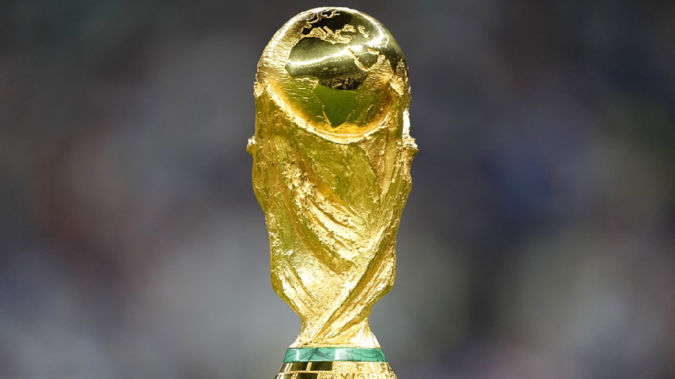
The media creates a perception of what people believe to be valuable. Men’s competition is visible, with male athletes at the top of the list during sports broadcasts. Indicators show that women’s sports receive less than ten percent of the total coverage globally. The United Nations Educational, Scientific and Cultural Organization (UNESCO) reports that women’s sports receive only about 8 percent of total global sports media coverage, even though women make up nearly half of all athletes (UNESCO, 2023). In addition, when they are portrayed, the level at which women are criticized as they play differs from that of men as the appearance and personality of a female athlete is discussed rather than the usual trick tactics that most commentators would prefer to discuss. UNESCO also finds that female athletes are more likely to be described using personal or appearance-based language, while men are framed through performance, tactics and competition (UNESCO, 2023). In doing so, it determines how the audience frames female athletes and how the sponsors choose to invest their money. If the media continues to portray a man’s sport as being real or true competition, it will always be difficult for audience to perceive and understand criticism.
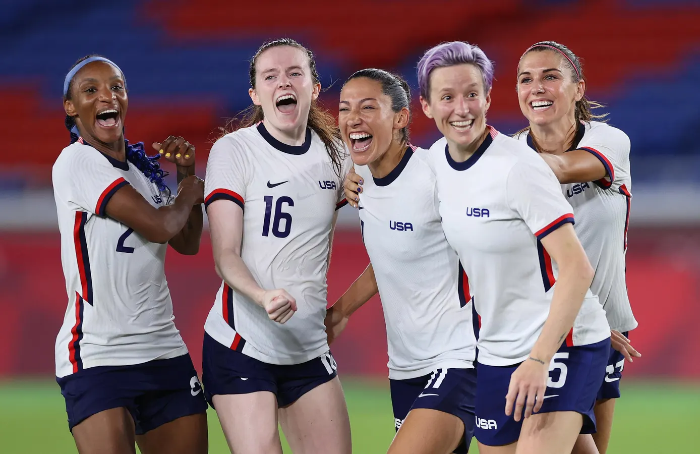
The disparity is not just financial, it is political. Investment in women’s sports is still lacking, from the lowest tiers to the highest professional leagues. Girls and women are given fewer chances, smaller budgets and limited access to elite professional coaches. Sports exemplifies a larger social structure in which the framework for inequality is established by the institution. Men’s activities are omnipresent and unrelenting, whilst women’s activities are deemed exceptional. The sector is polarized as the highest-ranked male athletes make considerably more money than their female counterparts. The U.S. Women’s National Soccer Team is a perfect example of how unfair this is. They have won several World Cups and have garnered huge fan support, yet earn much less than the men’s team, which did not perform as well. Between 2016 and 2019, US Soccer’s own financial reports showed that the women’s team generated about 50.8 million dollars in revenue compared to the 49.9 million dollars earned by the men’s team, yet the women were still paid less, proving the pay gap was not based on revenue (US Soccer, cited in BBC Sport, 2022). They eventually triumphed in 2022, but not just in terms of net price. It was a declaration that women’s achievements deserve the same respect and reward.
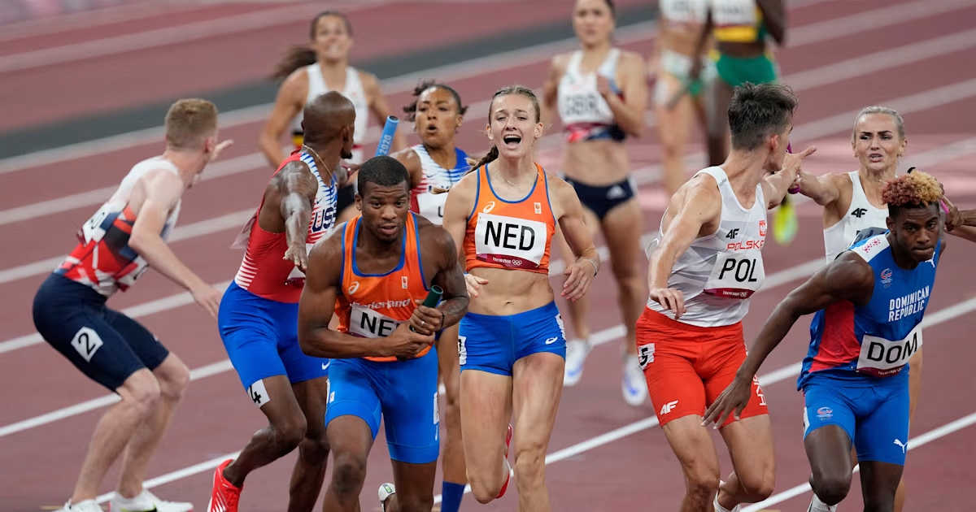
Today, new pressures make things even harder. Sociologists say we live in a time when people are told to take full responsibility for their success or failure. Instead of investing as an institution, women are asked to market themselves, told to “build their brand” on social media to attract sponsors. The line between athlete and influencer is blurry. Women are granted crumbs, a handful of short contracts, minimal maternity pay and lengthy warnings. The risks of losing crucial sponsorships, societal backlash and lawsuits loom overhead if they protest. Closing the gender pay gap is more than equalizing prize money. This passage encompasses years of unequal investment, unbalanced media coverage and societal memes that devalue women’s jobs. It requires rethinking about what is valued in sports and committing to long-term funding, equal media coverage and fair representation.
Equality in sport isn’t about quotas; it’s about redefining the political economy of what deserves our attention and our admiration. Female athletes are repeatedly showing they can compete at the top and motivate millions everywhere. The system must have the comparable care, attention and respect for their work that males have benefited from for years. So, it’s not just about money when it comes to saving equal pay; it’s about dignity and rights as well. Sports unite people and demonstrate the possibility of forming an equal world with equal pay for the next era. The only thing that remains is to ask those in charge if they are prepared to put their money where their mouth is.

References

Sport, Bbc. 2022. “US Women’s National Team Reach Agreement With US Soccer Over Equal Pay.” BBC Sport. February 22, 2022. https://www.bbc.com/sport/football/60480155.

Kassouf, Jeff. 2023. “‘We’re Used to Scraps’: How $30,000 Guarantees Will Change World Cup Players’ Lives.” The Guardian, August 7, 2023. https://www.theguardian.com/football/2023/aug/03/womens-world-cup-2023-prize-money-player-payments.

“Gender Equality in Sports Media.” 2023. UNESCO. April 20, 2023. https://www.unesco.org/en/gender-equality/sports-media.

Gowdy, Kristen. 2019. “The Fight for Equal Pay in Women’s Sports - Women's Sports Foundation.” Women’s Sports Foundation. October 10, 2019. https://www.womenssportsfoundation.org/education/fight-equal-pay-womens-sports/.

